A selection of mountain value chains: Private sector valorisation of natural capital?
Mountain Value Chains Report, November 2021
Kirsty Blackstock¹, Rachel Creaney¹Jon Hopkins¹ and Sharon Flanigan¹
¹ Social, Economic and Geographical Sciences Department, James Hutton Institute, Aberdeen, UK
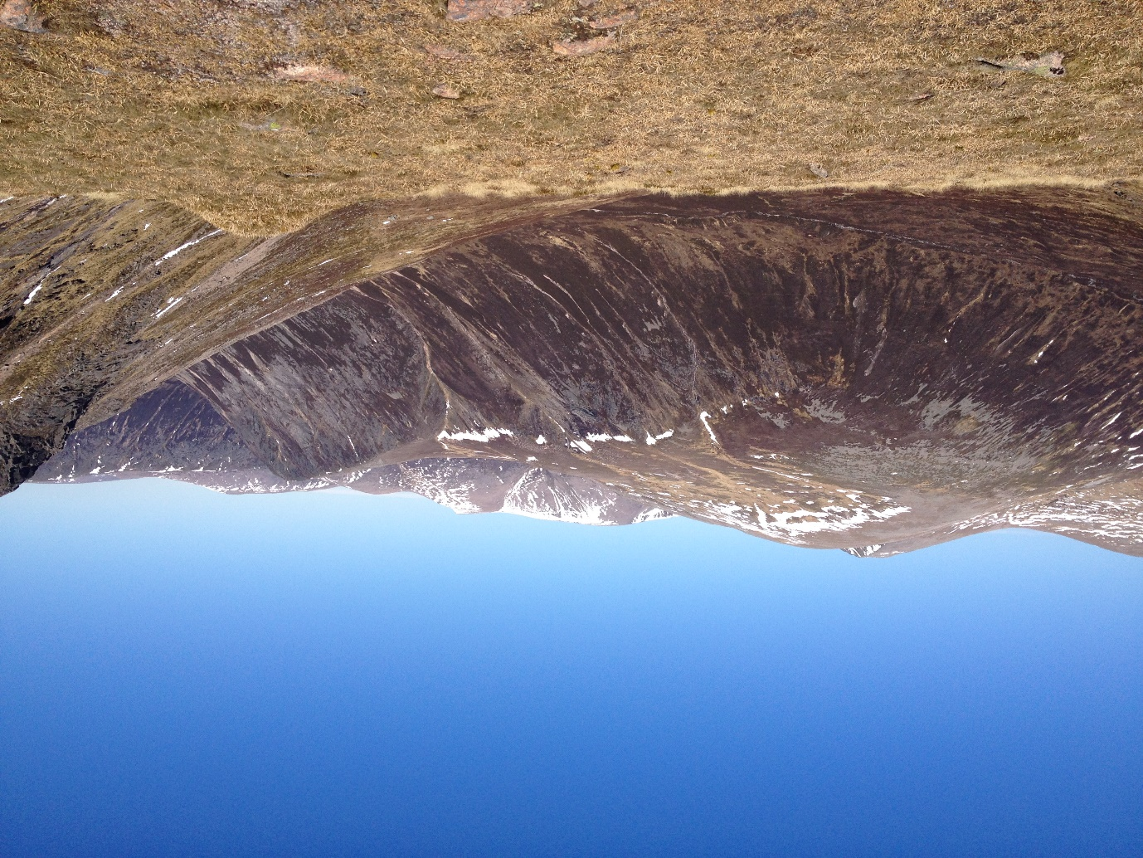

Summary
The H2020 MOVING MOuntain Valorisation through INterconnectedness and Green growth) project collected over 470 examples of value chains across European mountains. Value chains consider how place-based capitals (natural, social, financial etc) are transformed through processing, distribution and consumption to final market and non-market values. Mountains are considered both particularly vulnerable to environmental and social change, yet also particularly rich in natural and social, if not economic, capital. Therefore, there is considerable interest in taking a mountain perspective on sustainable development.
Although Scotland does not have a specific mountain policy, Scotland contains internationally important upland areas, and a large spatial area of Scotland can be classified as ‘mountainous. Land based fragility (based on altitude, slope, and soil) does not always mean socio-economic fragility, where areas can harness natural capital for profitable value chains. However, land-based fragility (due to altitude, soil, and slope) is not always linked to socio-economic fragility – some upland areas report population growth and prosperity compared to others in decline. This report therefore highlights a range of traditional and emerging mountain value chains to raise awareness of their dependence on natural and other capitals; and highlight how value chains link across multiple policy domains. This scoping shows there is potential for these value chains to be harnessed as part of Scotland’s approach to a green recovery in rural areas.
- The selection of value chains covers food and drink; recreation and tourism; materials; and utilities including production of public goods.
- Some value chains have a long tradition in Scotland, others have emerged in the last few years. In some cases, previously important products have been revitalised.
- ‘Mountain’ areas are heterogenous in terms of population and economic indicators. However, data to allow international comparison is often only available at spatial scales that include lowland and urban settlements.
- Value chains rely on natural capital and often a range of value chains draw on the same landscapes. However, socio-cultural, and economic capitals are also essential to value chains.
- The Government and NGOs play an important enabling role in terms of funding, regulating, and encouraging value chains in these mountain areas.
- In many cases, it is unclear how much value is added in the mountains, but the imagery of mountains is important for their marketing.
- Many value chains are innovating to respond to the climate and biodiversity crises through adapting their processing and distribution practices in these mountain areas.

1: Introduction
Within Scotland, the search of a green recovery from the impacts created by climate change, biodiversity decline and Covid 19 has often involved two important aspects: natural capital and the role of the private sector. Value chains, the process by which value is added through production, processing, distribution, and consumption, allow the analysis of how private firms are involved in these chains and the outcomes produced at each stage. Increasingly, value chains are being considered not only in terms of their economic value-added, but extended to consider how these chains involve social, cultural, human, and natural capitals.
Natural capital requires us to understand, protect and invest in our natural assets (flora, fauna, water, soil, geology) which are the stocks, or funds, that underpin the flows of ecosystem services and benefits to society. Recognising our reliance on natural, as well as human, social and financial capitals, is fundamental to true sustainability. If natural capital is depleted, it not only jeopardises current societal arrangements, but the abilities of future generations to enjoy the same quality of life. Conversely, timely protection of natural capital safeguards the options for current and future societies. This understanding is conveyed by the increasing emphasis of natural capital in the recent Programmes for the Scottish Government.
Natural capital is also an important aspect of value chains, particularly those within the food and drink sector. Private enterprises, from micro businesses to global multi-national corporations, are increasingly recognising the need to improve the resilience of their supply chains, and to protect the natural assets on which the value-added process depends. Increasingly, this is not solely the material natural assets, but also the symbolic and cultural values associated with clean and green mountain regions (Paul & Santamaria, 2021). This mirrors the emphasis on healthy and sustainable food in the Scottish Good Food Nation Policy.
Mountain areas provide a great deal of our global natural capital, including the freshwater on which half the world’s population depends (FAO, 2011). However, mountain areas are vulnerable to the changes brought by climate change, habitat degradation, land use change, and changing socio-demographics. Indeed, part of the SDG 15 (Life on Land) explicitly recognises the need to take a mountain-specific lens on sustainable development, given their particular governance challenges (Tucker et al, 2021). Ongoing research in a H2020 project MOVING (MOuntain Valorisation through INterconnectedness and Green growth) combines the focus on private sector and natural capital, by exploring which value chains are found in mountain regions across Europe.
This report gives a short overview of how ‘mountains’ in Scotland were defined; and a range of value chains associated with these mountain regions. The aim of the report is to raise awareness of the need to connect policy domains from the primary production sector (farmers, foresters and estates who manage most of the mountain natural capital) to the private sector actors involved in processing, distribution, and retail/tourism sectors.
A companion video is also available here: [final link will be uploaded when finalised]

2: Approach
Scotland does not have a specific mountain policy, reflecting the situation at the UK and EU levels. A great deal of a Scottish agricultural land was designated a ‘less favourable area’ due to a combination of altitude, soil and other factors that make primary production more challenging. This broad definition covers much more land than areas defined as mountainous (see also EEA, 2010). The current post-Brexit discussions about how to manage rural land include recommendations from the ‘hill, upland and crofting’ farmer led groups. Useful background on specific needs of upland areas can be found in the Vision for the Uplands (SNH, 2016).
The MOVING project followed the EEA (2010 p29) definition of mountain areas based on altitude, slope, terrain and local elevation range to take account of strong local contrasts (steep slopes close to lowlands). Figure 1 below highlights the Scottish Mountain areas considered with the MOVING project.
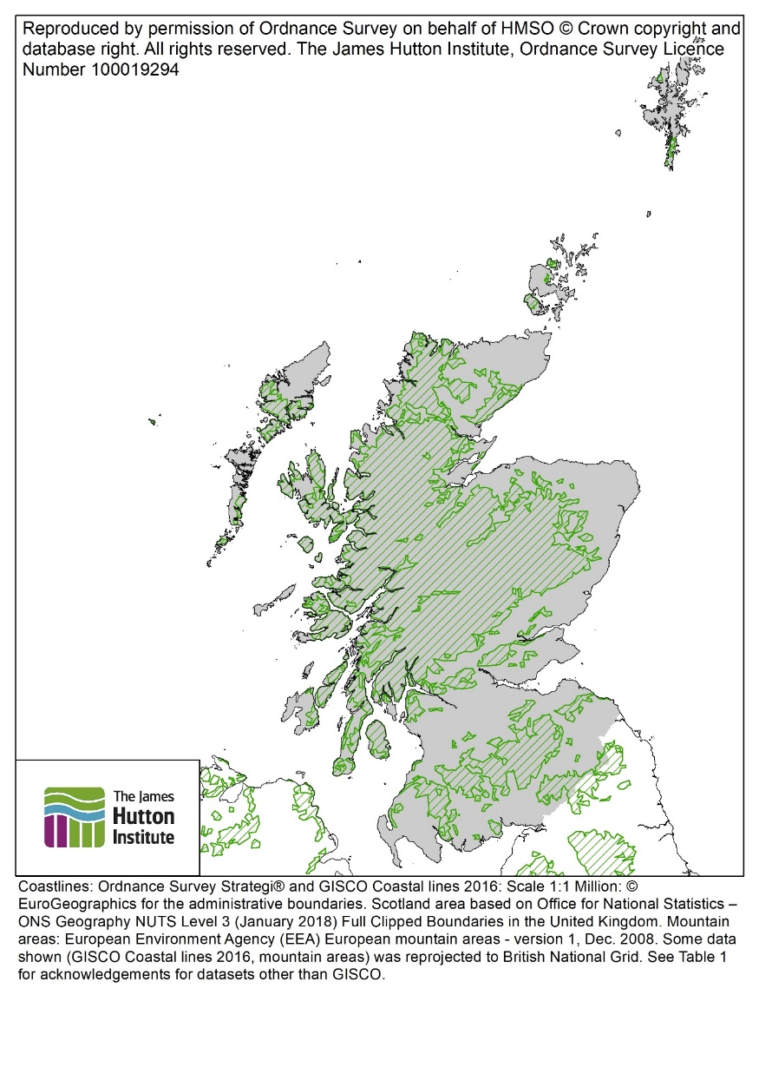
Figure 1: Map showing Mountain Areas (green outline and hatching) in Scotland (grey area). Image: Jon Hopkins.
Data for socio-economic factors is collected based on administrative not altitudinal boundaries. The Local Administrative Units (LAUs) assessed in Scotland include land below 600m altitude, with many having land at lower levels facing significant natural constrains (due to soil conditions and terrain). Within Scotland, these are the five areas that were focused on for mountain value chains (Table 1). Note the differences between spatial area defined as mountainous; and the proportion of population living there. Some mountainous areas are much more sparsely populated than others (compare the Dunbartonshire area with Lochaber for example).
Table 1: Land and Population in NUTS3 regions with +50% EEA mountain area
NUTS 3 Regions | % Area within EEA Mountain Area | % Population within EEA Mountain Area
Caithness & Sutherland and Ross & Cromarty | 53.5 | 9.0
East Dunbartonshire, West Dunbartonshire, and Helensburgh & Lomond | 59.4 | 7.0
Inverness & Nairn and Moray, Badenoch & Strathspey | 70.6 | 7.1
Lochaber, Skye & Lochalsh, Arran & Cumbrae and Argyll & Bute | 75.4 | 39.7
Perth & Kinross and Stirling | 70.5 | 11.5
Source: derived from analysis of spatial datasets and Census 2011 data - Office for National Statistics – ONS Geography NUTS Level 3 (January 2018) Full Clipped Boundaries in the United Kingdom: http://www.nationalarchives.gov.uk/doc/open-government-licence/, Contains National Statistics data © Crown copyright and database right [2017]; European Environment Agency (EEA) European mountain areas - version 1, Dec. 2008: Copyright holder: European Environment Agency (EEA); Ordnance Survey Strategi® data: Contains Ordnance Survey data © Crown copyright and database right 2016; Department of Agriculture, Environment and Rural Affairs (DAERA) Northern Ireland Lake Water Bodies: Contains public sector information licensed under the Open Government Licence v3.0. https://www.nationalarchives.gov.uk/doc/open-government-licence/version/3/; National Records of Scotland Census 2011 - Output Area Centroids: Copyright National Records of Scotland, contains Ordnance Survey data © Crown copyright and database right (2020); Office for National Statistics - ONS Geography Output Areas (December 2011) Population Weighted Centroids: http://www.nationalarchives.gov.uk/doc/open-government-licence/, Office for National Statistics licensed under the Open Government Licence v.3.0.; Northern Ireland Statistics and Research Agency Small Area Boundaries in GIS format. Based upon Crown Copyright material with the permission of Land & Property Services under delegated authority from the Keeper of Public Records, © Crown Copyright and Database Right MOU577.[2022]; National Records of Scotland Census 2011 (2011 census table data: Output Area 2011 - Table KS101SC): © Crown copyright. Data supplied by National Records of Scotland.; Office for National Statistics Census 2011 (Table KS101EW - Usual resident population): ONS Crown Copyright Reserved [from Nomis on 26 October 2020]. Source: Office for National Statistics.; Neighbourhood Statistics, NISRA Census 2011 (Usual Resident Population: KS101NI (statistical geographies)): © Crown copyright.
The methodology adopted in MOVING was not to undertake a census of all value chains, but to provide an overview of the range of value chains available. The approach covered all the UK but was mainly focussed on Scottish value chains. The data collected covered both quantitative information on size, population density, population change, employment etc and qualitative information on why the value chain had emerged and the forms of innovations being utilised to respond to climate and other drivers.

3: Results
This section highlights some of the aspects of the Europe-wide inventory of interest to Scottish Government. Section 3.1 illustrate the range of value chains in mountain areas and how they extend beyond the traditional primary sector (agriculture, forestry, and fisheries) into utilities, craft, food and drink processing and tourism. Section 3.2 illustrates the socio-economic context of the most ‘mountainous’ NUTS3 areas, illustrating again the importance of secondary (manufacturing) and tertiary (service and government) sectors for local employment and productivity. Section 3.3 briefly describes the capitals (natural and otherwise) that underpin the value chains described in Section 3.1. Full results for all 25 UK value chains can be found here (see p 581-– 630).

3.1: Value Chains
The MOVING deliverable lists 18 value chains found across the five NUTS3 regions listed in table 1. There were a further eight value chains identified and described in English and Welsh mountain regions. However, in all except one case, these value chains can also be found in Scotland, so all 25 value chains were analysed. As described above, this is not an exhaustive list of all value chains but represents the diversity of value chains found in Scottish mountain areas.
Food and Drink
The range of food and drink ‘mountain’ products include:
- Breakfast puddings
- Gin
- Heather Honey
- Scotch Lamb
- Mineral Water
- Scotch Beef
- Scotch Whisky
- Venison

The analysis considered a wide range of food from livestock commodities (Scotch beef, breakfast puddings, lamb) to more niche products (venison, both wild and farmed) that are produced in mountain regions. Drinks, particularly Scotch Whisky, are an important part of the mountain value chain picture, given their importance to export markets and taxation returns. Only a few of these value chains have formal protected geographical status (Scotch Whisky, Stornoway Black Pudding, Scotch Beef, Scotch Lamb which all have PGI status). This is quite different from the rest of the MOVING inventory (particularly in central and southern Europe), which includes many regional dairy products, berries, grains, and vegetables.
Recreation and Tourism
The range of recreation or tourism ‘mountain’ products include:
- Adventure Tourism
- Fly fishing (Salmon)
- Hill Walking
- Nature Tourism
- Sporting game (Deer)
- Winter Sports

The analysis included traditional upland pursuits that make up much of private estates’ business models, as well as newer forms of tourism. Some of these different value chains co-exist in space, such as hillwalking and deer stalking; or kayaking with fly fishing. Some summer adventure tourism has developed to extend the season and use the existing infrastructure associated with winter sports, given the variability of snow availability in recent years. Rural tourism was also important in many other MOVING regions, although there was more focus in other European areas on gastronomic and farm stay tourism and less on the active recreational value chains.
Fibre and Materials
The range of material ‘mountain’ products include:
- Artisan wood Products
- Beeswax products
- Forestry Timber
- Heather Jewellery
- Mountain wool (Harris Tweed)

The analysis included commodities such as timber from plantation forestry, but also emerging niche products such as beeswax products (often in conjunction with honey, listed above), heather jewellery and furniture or craft from native, often windblown, timber sources. Mountain wool, particularly Harris Tweed, is an example of the re-emergence of a declining value chain – wool was once a staple fibre for clothing and furnishings but has been largely replaced by synthetic or imported fabrics. However, the Harris Tweed Act (1993) ensures that tweed production remains on the Western Isles, even though most of the wool is imported, and the brand commands high prices. Forestry and timber were important across the other European regions, but other material-based value chains were less commonly reported.
Utilities and Public Goods
The range of other products include:
- Drinking Water
- Highland cows breeding
- Hydropower
- Investment in carbon sequestration
- Rewilding
- Wind power

Highland cattle were included here although they are also farmed for meat, due to their importance in breed stock and a cultural signifier in tourism and heritage. Some of these value chains are emerging and reflect the increased interest of non-traditional landowners purchasing uplands for potential investment in carbon or other markets; or out of philanthropy to pursue conservation aims. However, others reflect the importance of mountain areas in terms of utility value chains. Water and Energy are the other two parts of the fundamental Water-Energy-Food security nexus that is becoming increasingly important in terms of national resilience and security. The focus on renewables is also an important response to the climate emergency. However, very few other areas in the MOVING project identified water, public goods, or energy as value chains for their mountain regions.

3.2: Socio-Economic status of ‘Mountain’ Regions
Tables 2-5 provide some data for Scottish mountains in the Highlands and Islands. However, often data to allow comparison with other MOVING cases across Europe is only available at NUTS3 level or equivalent, meaning the data will also include lowland and urban populations.
The areas vary in size, population density & population dynamics as shown in Table 2 below. The largest values are in bold. Population density varies tremendously, illustrating the influence of major conurbations nearby. Many of these regions have seen population increases, including those with low population density. However, depopulation continues in the North and West, including in areas with relatively dense populations.
Table 2: Socio-demographic characteristics of LAU1 regions
Local Administrative Units (1) | Size of area (km²) | Population density (inhabitants in 2019/km²) | Population change (2009-19)
Aberdeenshire | 6,318 | 41.3 | 4.90%
Arygll & Bute mainland | 4,494 | 11.8 | -4.85%
Badenoch & Strathspey | 2,370 | 5.9 | 6.53%
Caithness & Sutherland | 7,862 | 4.9 | -3.43%
Helensburgh & Lomond | 381 | 67.8 | -1.89%
Inverness & Nairn | 3,332 | 28.5 | 6.50%
Lochaber | 4,655 | 4.3 | 0.50%
Na h-Eileanan Siar | 3,092 | 8.6 | -2.55%
Perth & Kinross | 5,384 | 28.2 | 5.25%
Ross & Cromarty | 5,202 | 10.7 | 2.44%
Skye & Lochalsh | 2,742 | 4.8 | 2.84%
Source: derived from analysis of spatial data and population data - Office for National Statistics - ONS Geography Local Administrative Units Level 1 (January 2018) Full Clipped Boundaries in United Kingdom: http://www.nationalarchives.gov.uk/doc/open-government-licence/, Contains National Statistics data © Crown copyright and database right [2017]; National Records of Scotland (NRS) Local Administrative Units (LAU1) Population Estimates by sex and single year of age, 2001-2019. [Microsoft Excel Workbook]. © Crown Copyright 2020.
The areas vary in terms of average income, employment, and productivity. The largest values are in bold. Most areas have low GVA and employment figures for the primary sector, although the North-West (Lochaber, Skye & Lochalsh, Arran & Cumbrae and Argyll & Bute) has predominantly more employment and value added based on the primary sector than the other regions. In all cases, the tertiary sector dominates the GVA and employment. However, the statistics are for the NUTS3 region and will represent an average between urban and remote rural – smaller areas may have higher dependence on the primary sector than it currently appears.
Table 3: Economic performance of NUTS3 Regions (all data: 2018)
 |  | % share of total GVA |  |  | % share of total employment
NUTS 3 Regions | Average per capita income (EUR)/year | Primary sector | Secondary sector | Tertiary sector | Primary sector | Secondary sector | Tertiary sector
Aberdeen City & Shire | 24,464 | 2.5 | 28.1 | 69.5 | 3.3 | 23.1 | 73.6
Caithness & Sutherland and Ross & Cromarty | 22,243 | 4.1 | 22.6 | 73.3 | 8.2 | 16.3 | 75.5
East Dunbartonshire, West Dunbartonshire, and Helensburgh & Lomond | 23,566 | 0.2 | 21.3 | 78.5 | 1.4 | 15.9 | 82.6
Inverness & Nairn and Moray, Badenoch & Strathspey | 22,078 | 1.4 | 35.0 | 63.6 | 6.8 | 20.5 | 72.7
Lochaber, Skye & Lochalsh, Arran & Cumbrae and Argyll & Bute | 21,200 | 5.4 | 22.1 | 72.5 | 6.3 | 16.7 | 77.1
Na h-Eileanan Siar | 20,263 | 4.6 | 14.1 | 81.3 | 21.4 | 14.3 | 64.3
Perth & Kinross and Stirling | 24,366 | 3.1 | 30.8 | 66.2 | 4.5 | 17.0 | 78.6
Source: derived from analysis of Office for National Statistics Regional gross disposable household income: all NUTS level regions: © Crown copyright 2020, Source: Office for National Statistics licensed under the Open Government Licence (for Average per capita income, GDHI per head of population at current basic prices cited, converted using 31 Dec 2018 exchange rate (£1: €1.130081 - https://www.ofx.com/en-gb/forex-news/historical-exchange-rates/yearly-average-rates/)); Eurostat Gross value added at basic prices by NUTS 3 regions [nama_10r_3gva]. (http://appsso.eurostat.ec.europa.eu/nui/show.do?dataset=nama_10r_3gva); Eurostat Employment (thousand persons) by NUTS 3 regions [nama_10r_3empers] (https://appsso.eurostat.ec.europa.eu/nui/show.do?dataset=nama_10r_3empers&lang=en
Following on from table 3, the primary sector may not be a large employer, but there are several holdings in agricultural sub-regions that include mountain areas (Table 4). Table 4 does not give the detail for the specific mountain areas within the sub-regions, nor the size of these holdings. However, it illustrates the potential range of producers that manage land utilised by the value chains described in Section 3.1.
Table 4: Agricultural Holdings: regional data
Agricultural subregion | Number of agricultural holdings (2019)
Argyll & Bute | 1,944
Grampian | 8,612
Highland | 10,230
Na h-Eileanan Siar | 6,293
Tayside | 3,635
Source: Scottish Government (2020) Economic Report on Scottish Agriculture tables: 2020 edition (Table C1, data: June Agricultural Census, 2019). Available online
Furthermore, consistent with the importance of the tertiary sector illustrated in Table 3 above, Table 5 shows that the most mountainous NUTS 3 regions (see Table 1) have relatively large shares of the tourism accommodation. As with Table 4, the data is not taken only from mountainous areas and will include urban and peri-urban tourist beds (e.g. Aberdeen City and Shire). However, visitor demand for mountain areas (such as Scotland’s two national parks) suggests mountain value chain analyses should involve tourism as well as food and drink value chains. Indeed, World Mountain Day in 2021 celebrated mountain tourism for its role in sustainable rural development.
Table 5: Tourism Bed Places of NUTS3 Regions
NUTS3 Region | Total bed places (BPs) in tourist accommodation/year (2011)
Aberdeen City & Shire | 14,233
Caithness & Sutherland and Ross & Cromarty | 8,124
East Dunbartonshire, West Dunbartonshire, and Helensburgh & Lomond | 2,660
Eilean Siar | 2,407
Inverness & Nairn and Moray, Badenoch & Strathspey | 15,574
Lochaber, Skye & Lochalsh, Arran & Cumbrae and Argyll & Bute | 29,913
Perth & Kinross and Stirling | 21,499
Source: Eurostat Number of establishments, bedrooms and bed-places by NUTS 3 regions (1990-2011) [TOUR_CAP_NUTS3]. Available online
Nearly all the areas studied have an EU designation for conservation, such as being a Special Area of Conservation, Special Protection Area for Birds or Sites of Community Importance. Although Helensburgh and Lomond do not have EU designation, there are other national designations applying. Therefore, all the areas have national or international significance in terms of their natural capital. This is further developed in section 3.3 below.
Table 6: Protected Area Designations in LAU1 Regions
LAU1 areas | Number of protected areas (SAC, SCI, SPAs): based on central points of sites (2020)
Aberdeenshire | 25
Argyll & Bute mainland | 10
Badenoch & Strathspey | 13
Caithness & Sutherland | 32
Helensburgh & Lomond | 0
Inverness and Nairn | 15
Lochaber | 18
Na h-Eileanan Siar | 24
Perth & Kinross | 23
Ross and Cromarty | 28
Skye & Lochalsh | 9
Source: derived from analysis of a) Joint Nature Conservation Committee Natura 2000 (N2K) site summary details spreadsheet 2020: Contains public sector data © JNCC/NE/NRW/SNH/DOENI. Licence: OGL. ('Basic site details for each and every SAC (including candidate SACs, SCI and designated SACs)' and 'Basic site details for each and every Special Protection Area (SPA)' sheets.); b) Office for National Statistics - ONS Geography Local Administrative Units Level 1 (January 2018) Full Clipped Boundaries in United Kingdom: http://www.nationalarchives.gov.uk/doc/open-government-licence/, Contains National Statistics data © Crown copyright and database right [2017].

3.3: Reliance on Mountain capitals
The inventory sought to illustrate how local mountain assets are used to support local rural industries, sometimes worth several million pounds to Scotland (e.g., Deer Stalking worth over £100 million (PACEC, 2016); Scotch Whisky exports were worth £4.9billion at 2019 prices (Scotch Whisky Association, 2021). However, it is unclear how much of the final value of these products accrue to the individuals living and working the mountain regions.
All the value chains rely on the mountain natural resource systems. Many rely on the same land cover and land use e.g., heather moorland and permanent grassland used for rough grazing will support deer, sheep and cattle involved in the highland cattle, beef, lamb, breakfast goods, wool, and sporting value chains; whilst also providing the habitat for bees in the honey and beeswax value chains; and the flora for the jewellery and gin value chains. The same landscape provides the backdrop for the recreation and tourism value chains, with the open vistas characterising iconic Scottish viewpoints from Munros. Traditionally, plantation forestry for timber value chains has focussed on the edges of the uplands, although there are rewilding and reforestation projects seeking to plant native, rather than commercial spruce, forestry in the uplands for carbon and biodiversity outcomes. These trees are used in artisan wood value chains. These habitats are also utilised by tourism value chains, such as nature safaris. Winter sports rely more on the weather and topography than land cover, with cross-country sports often taking place within wooded landscapes and down-hill sports on higher moorland. Onshore wind energy also harnesses the topography and weather systems. Finally, these upland terrestrial ecosystems form the catchments for surface and ground waters which are the essential building blocks for fisheries, mineral waters, drinking water, hydro power and inputs to whisky and gin. As section 3.2 Table 3 above might suggest, the natural capital here is not only harnessed for food and drink production: but also, as the landscape for the important tourism sector.
Other capitals are involved in the value chain. In many cases, traditions and culture explain the development and persistence of value chains, which amplifies concerns over rural depopulation in the North-West (Table 2). In all cases, economic investment in infrastructure for the processing, transport and distribution is essential, as well as enabling tourists to consume the mountain products at source. Although value chain analysis highlights the role of private firms, the inventory illustrates the importance of an enabling environment, with supporting financial, regulatory and knowledge institutions to drive innovation, involving the State and NGOs. There are several cases in which ‘traditional’ value chains, such as deer stalking or cattle breeding, are adopting technological innovations to monitor populations, and manage both the herds and their habitats more sustainably. In other value chains, particularly where commodities are processed in mountain areas, industries such as winter sports, whisky, and mineral water production are seeking to become carbon neutral and nature positive through using renewable energy, reducing water and waste, reducing food miles through different packaging or transport, and investing in nature friendly management practices on their land.

4: Next Steps
This report provides a Scottish lens on the initial phase of the MOVING project. Overall, as highlighted in the summary at the start, there is a diverse range of value chains reliant on Scotland’s natural capital originating in mountainous areas. These value chains are not only based on primary production but also include manufacturing and service industries; with emerging opportunities arising from the provision of public goods.
From these examples, the Speyside Malt Whisky value chains was selected as the focal value chain for further analysis. It will illustrate how the Cairngorms provide essential natural resources (surface and groundwater) for a global value chain and how the individual distilleries are woven into a wider local food and drink tourism industry.
The current focus is an assessment of the vulnerability of surface water, a major input to the Speyside Malt Whisky value chain, to climate change. An assessment of the overall sustainability performance of the Speyside Malt Whisky value chain will begin in Spring 2022. For more information, please see the overall project website here and the Scottish case website here or contact: Kirsty Blackstock (kirsty.blackstock@hutton.ac.uk).

5: References
EEA (2010) Europe’s ecological backbone: recognising the true value of our mountains. EEA Report No6/2010 https://www.eea.europa.eu/publications/europes-ecological-backbone
FAO (2011) Why Invest in Sustainable Mountain Development? Report available online: https://www.fao.org/3/i2370e/i2370e.pdf
Global Tourism Solutions (2018) Cairngorms National Park STEAM Tourism Economic Impacts 2018 Report https://cairngorms.co.uk/wp-content/uploads/2019/08/CNP-2018-Narrative.pdf
Moretti M, Felici F, Allali T, Scotti I and Brunori G (2021) D4.1: Inventory of Mountain Value Chains. Available online: https://www.moving-h2020.eu/wp-content/uploads/2021/06/D4.1_Inventory-of-Mountain-Value-Chains_web.pdf
Paül, V., & Trillo-Santamaría, J.-M. (2021). The Emerging Mountain Imaginary Of The Galician Highlands: A New National Landscape In An Era Of Globalization? Geographical Review, 1-27. doi:10.1080/00167428.2021.1897812
PACEC on behalf of the Association of Deer Management Groups (2016) The contribution of deer management to the Scottish Economy: Final Report. http://www.deer-management.co.uk/wp-content/uploads/2016/02/Final-25FEB.pdf
Scotch Whisky Association (2021) Facts and Figures. https://www.scotch-whisky.org.uk/insights/facts-figures/
Scottish Natural Heritage (2016) Scoping a strategic vision for the uplands: report from SNH to the Scottish Government. Online: https://www.nature.scot/sites/default/files/2017-10/A2195474%20-%20Scoping%20an%20upland%20vision.pdf
Tucker, C. M., Alcántara-Ayala, I., Gunya, A., Jimenez, E., Klein, J. A., Xu, J., & Bigler, S. L. (2021). Challenges for Governing Mountains Sustainably: Insights From a Global Survey. Mountain Research and Development, 41(2). Retrieved from https://doi.org/10.1659/MRD-JOURNAL-D-20-00080.1

Acknowledgements
This work was funded by the Rural & Environment Science & Analytical Services Division of the Scottish Government, as part of the Strategic Research Programme 2016-2021 (RD2.4.2 – How rural industries can adapt to external drivers). It builds on a published deliverable from the H2020 project MOVING (MOuntain Valorisation through INterconnectedness and Green growth). MOVING receives funding from the European Union’s Horizon 2020 research and innovation programme under grant agreement No. 862739. The opinions expressed in this report do not necessarily reflect those of the European Commission, Scottish Government or RESAS. Any errors in analysis or interpretation are those of the authors.

https://www.gov.scot/groups/hill-upland-and-crofting-group/
This is also the case for other MOVING partners. Across the MOVING project, all partners have selected LAUs where at least 50% of the area is within the designated mountain boundary (see Table 1). In general, MOVING cases occur in Southern, Central or Eastern Europe where primary production (timber, crops, livestock) is more viable in upland areas. The focus in MOVING is on how value chains can thrive despite these biophysical constraints on production, and comparisons of cases have to account of latitude, socio-economic context, and land use systems as well as altitude.
NUTS Nomenclature des Units Territorials Statistiques
PGI means Protected Geographical Indication: products that are produced, processed or prepared in a specific area. Due to the UK withdrawal from the EU, the UK now has a separate scheme governed by the same rules as the EU.
For example, visits to Cairngorms National Park increased 29% (2009-2018) (Global Tourism Solutions, 2018).

